**What is Maia?**

Maia is an AI system consisting of multiple artificial intelligence models, which provides solutions to help manage everyday tasks. Maia learns from user interactions, enabling you to upload personal documents and turn them into private knowledge bases on which you can ask questions. It’s a dynamic, ever-evolving system designed to deliver customized solutions.

1. **THE Maia CREDITS SYSTEM**

Maia works through the Maia Credits system which offers great flexibility as it deducts credits only for the features the user is interested in.

You can choose between two types of plans:

* Free Plan: 50 Maia Credits for free per month
* Elite Plan: 500 Maia Credits for 5€ per month

For more information, please refer to the “Pricing” section at the end of this document.

1. **HOW TO CREATE AN ACCOUNT**

To create a Maia account you need to register. First, go to the Maia website [at www.mymaia.ai](http://www.mymaia.ai) and navigate to the "Plans and Prices" page where you can choose between the Free and the Elite plans.

Once you have selected your plan, a registration form will appear. Fill out the provided fields to create your account on the Maia platform.

Please note that the form includes fields marked by red asterisks which are required in order to proceed with registration.

**Note: Your password must be 10 characters long, including 1 special character, 1 uppercase letter, 1 lowercase letter, and 1 number.**

We recommend filling out the “Interest”' field to help Maia learn more about you and provide personalized responses.

To make the most of Maia’s features, check the boxes labelled “Consent for localization” to perform local searches, and “Consent to use the microphone” to enable the Speech-to-Text mode and use your voice when interacting with your Life Copilot.

To complete your registration, click the “Register” button and check the email we will automatically send to your email account.

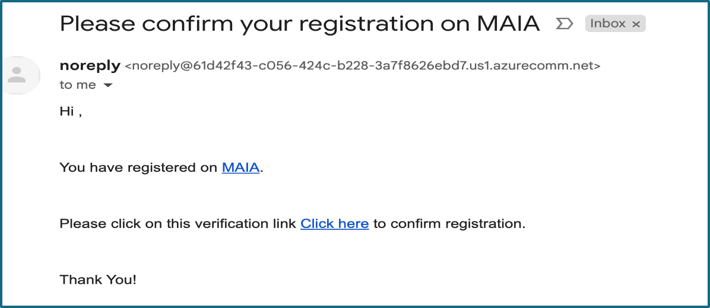

By clicking the blue “Click here” link, you will confirm your request to create a Maia account. This will lead you to the shopping cart page where you can complete the payment.

Once the payment is complete, you will receive a confirmation email and be automatically redirected to the Maia website. From there, you can access the service by entering your credentials.

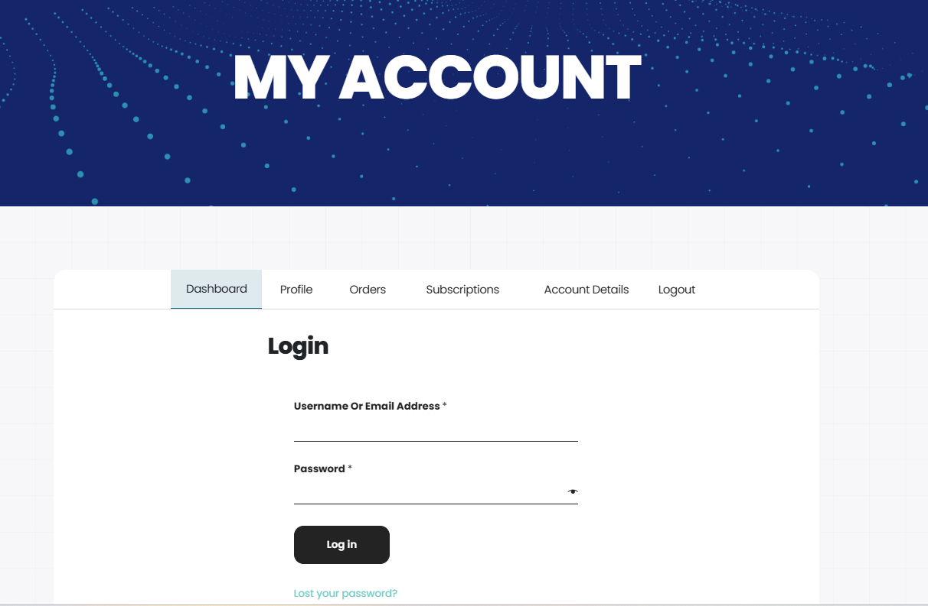

**2.1 How to log in to Maia next time**

For future logins, click the  button on the Maia website at [www.mymaia.ai](http://www.mymaia.ai). This will open the login screen, where you can enter your credentials to access the service.

If you forget your password, you can reset it by clicking the “Forgot your Password?” button on the login screen.

***IN A FEW CLICKS: How to create an account***

1. *Go to* [*www.mymaia.ai*](http://www.mymaia.ai)
2. *Navigate to the “Plans and Prices” page*
3. *Choose between the Free plan and the Elite plan*
4. *Fill in the registration form with the required information*
5. *Confirm your email address*
6. *Complete the payment*
7. *Click the*  *button*
8. *Enter your credentials*
9. *Click the “Log in” button*

***IN A FEW CLICKS: How to log in to Maia next time***

1. *Go to* [*www.mymaia.ai*](http://www.mymaia.ai)
2. *Click*  *button*
3. *Enter your credentials*
4. *Click the “Log in” button*

**2.2 How to download the Maia app onto your device**

Once you have registered and logged into Maia from your computer, you can also download the app onto your mobile. Go to the Maia website from your phone, scroll to the bottom of the page, and choose the operating system.

  
Once you click the Android or iOS icon, you will be redirected to your phone's app store to download the app.

**2.3 What the Maia panel looks like on the first login**

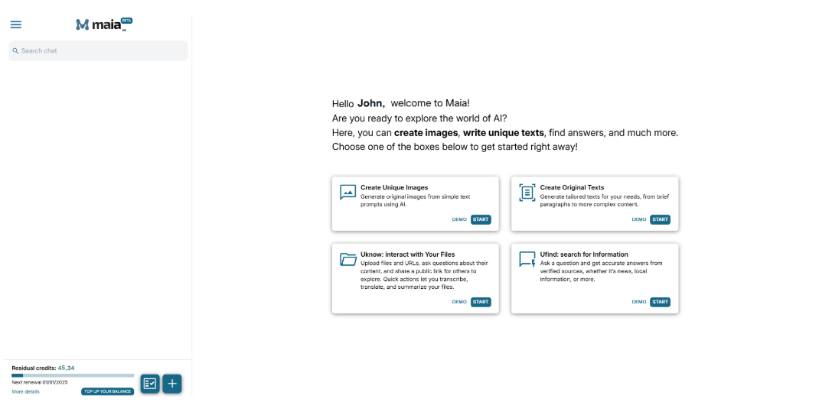

The Maia panel has two main sections: the right section is where the user can carry out searches, while the left section is where Maia keeps the conversation history.

The right section features 4 boxes, each divided by category:

* Create Unique Images
* Create Original Texts
* Uknow: interact with Your Files
* Ufind: search for information

Each box features a description of what Maia can do within a specific section.  
Click the “DEMO” button to view a practical example of how a section works or the “START” button to begin chatting with Maia.

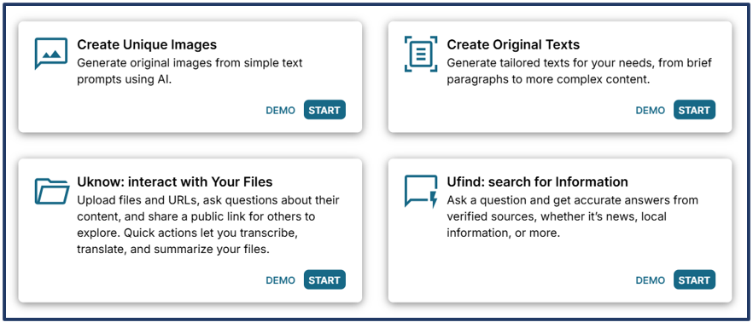

Once you enter a section, type your request into the search box, just like in a normal chat.



Please note that the microphone symbol  enables you to chat with Maia using your voice through Speech-to-Text technology.

At the top of the right section, the 3 icons  allow you to, respectively:

*  share your conversion on social media
*  change the name of your conversation
*  delete your conversation

On the left side of the screen, below the conversation history section, you will find the Maia credits bar.

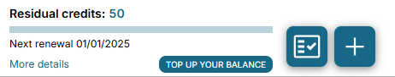

The bar displays the residual credits, the renewal date, and a "More details" button. Once you click the button, a pie chart will pop up showing how the credits have been spent according to your requests.

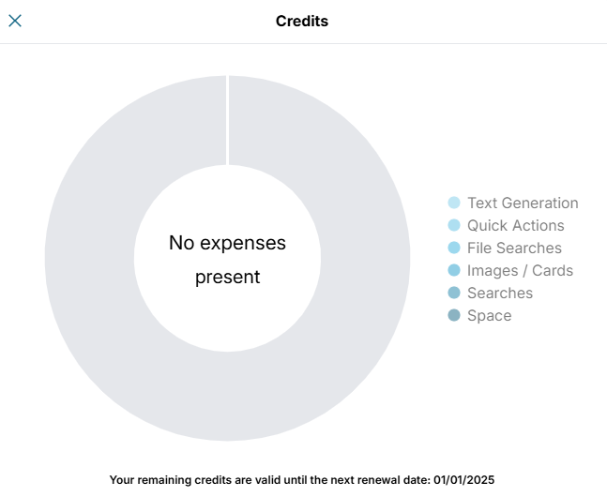

The credits update dynamically each time a task is completed, an answer is provided, or a search is performed. Next to the credit bar, you will find the icons . Click on the first button to select the chats you want to remove from the conversation list and on the second button to start a new chat.

In the top left corner, you will find the dropdown menu icon  with the following items:

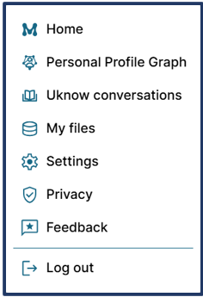

**3. CUSTOMISATION SECTIONS**

If you want Maia to provide custom answers, take some time to explore the panel sections dedicated to storing personal information and documents.

**3.1 Personal Profile Graph**

**3.2 My files**

The Personal Profile Graph, also known as PPG, is a tool that allows Maia to map users' interests, preferences, and personal information.

**Note: To fully benefit from Maia's potential, we suggest filling in the PPG with as much information as possible.**

The Personal Profile Graph is made of NODES, each representing a different category of information that the user can provide.

To access this section and add details, click the menu in the top left corner and select the “Personal Profile Graph” item.

The Personal Profile Graph is a network of NODES. In the centre, you will find a NODE labelled with your name that contains your basic information. In our example, the user's name is John, so the central NODE is "John".

From the central node, 7 other NODES branch out, each representing a specific category.

The categories are:

* **Physical appearance**. This section contains information about the user’s physical traits, such as body type, weight, eye and hair colour, and whether they wear glasses.
* **Job**. This section contains information about the user’s job, company and office location.
* **Education**. This section contains information about the user’s educational background and the languages they speak. Remember that here you can add as many languages as you like.
* **Family**. This section contains information about the user’s family members. If completed, it provides a full picture of their family, including their partner, children, parents, and siblings. You can also enter specifics such as each family member's name, age, and interests.
* **Passions**. This section collects the hobbies and passions the user first entered during registration. You can add more by typing them into the box.
* **Lifestyle**. This section contains information about the user’s diet, allergies, favourite foods and drinks, and travel preferences such as favourite vacation types and visited destinations. You can also add information about your favourite sports teams, the sports you practice, and what social media you are on.
* **Finance**. This section contains information about the user’s properties - for example, a two-room apartment at 42 Ellerdale Road, London - and their vehicles. You can also specify the horsepower and registration year for this last category.

As you enter your data, the graph will update, creating new connections and NODES, while the information added to the graph will appear in the right section.

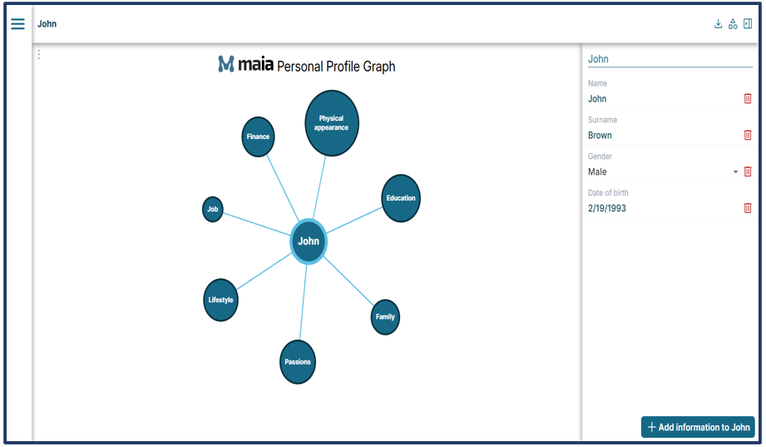

**3.1.1 How to enter information into your Personal Profile Graph**

On the right side of your Personal Profile Graph, you will find a button that says "Add information to John" . Once you click it, a dropdown menu will appear, showing the remaining details you can add to further enrich the central node, "John". Some of your data, like your first name, last name, date of birth, and gender, are already part of your graph as they were automatically added during registration. In this specific case, the information which has been left out is "Address" and "Residence."

***IN A FEW CLICKS: How to add information to your PPG***

1. *Click menu*
2. *Select “Personal Profile Graph” from the dropdown menu*
3. *Click “Add information to John”*
4. *Choose an item from the dropdown menu*
5. *Fill in the field with your data*
6. *Press “Enter”*
7. *Click “Save the change”*

**Note: Don’t forget to click “Save the change” after completing all fields in a NODE.**

**If you don’t save and move to another NODE in the graph, any unsaved information will be lost, and you will need to re-enter it.**

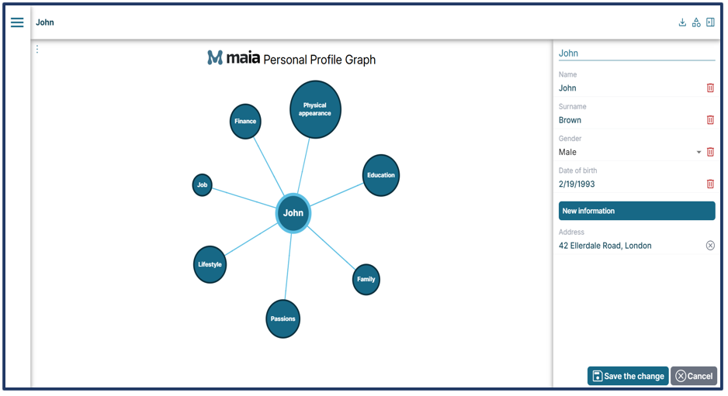

You can navigate your Personal Profile Graph by clicking the NODES in the left section or selecting any NODE in the central graph. This will take you to the corresponding category, where you can add your information.

Some NODES, like “Family,” “Job” “Passions”, and “Finance”, allow you to add second-level information. For example, if you add your partner’s name in the “Family” NODE, as first-level information, you can also specify their job, age, and passions, as second-level information.

**3.1.2 How to add second-level information**

After entering your life partner’s name (e.g., Lisa) into your PPG and saving the change, as we have seen before, a new NODE called “Lisa” will be automatically created. To add further information to this NODE, select it and click the “Add information to Lisa” button  found on the right.

Once you click the button you will see a dropdown menu with a list of further information, such as age, gender, interests and type of relationship.

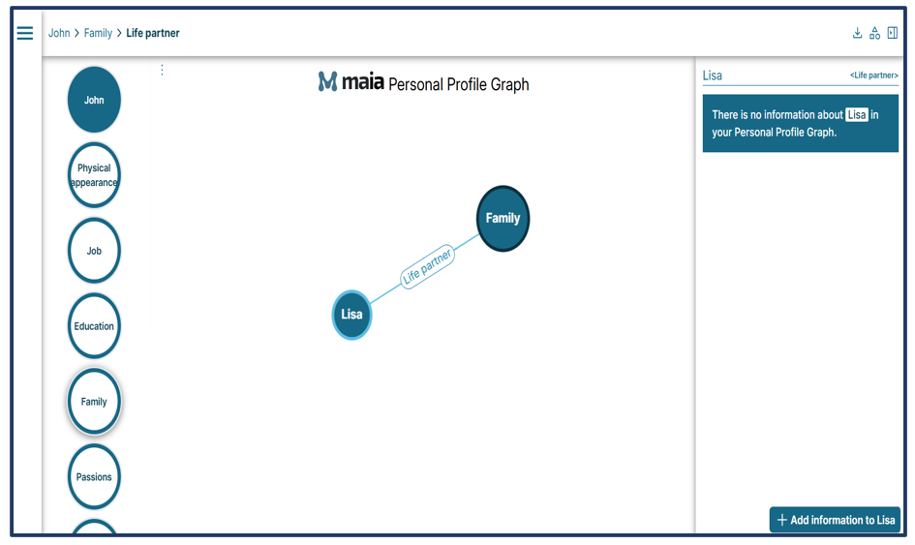

For example, if you enter your life partner’s age and click “Save the change” **,** your Personal Profile Graph will update and create an "Age" connection that links "Lisa" to the new NODE that features the age number.

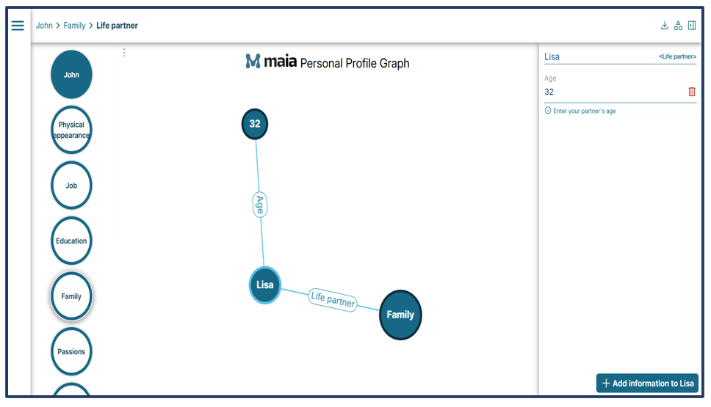

***IN A FEW CLICKS: How to add second-level information to your PPG***

1. *Click the menu and select the Personal Profile Graph item*
2. *Hover the mouse over the NODE you want to enrich, for example, “Lisa”*
3. *Click “Add information”*
4. *Select an item from the dropdown menu*
5. *Complete the field with your information*
6. *Press “Enter”*
7. *Click “Save the change”*

**Note: You can delete the information you entered anytime by simply clicking on the trash symbol  found next to each data.**

To re-enter information about your family members, you just need to click the “Family” NODE again.

If you don’t want certain NODES - for categories like physical appearance, education, job, family, passions, lifestyle, or finance - to be shown in your PPG, you can turn them off. Simply click the  icon in the top right, select the NODES you want to disable and click "Save" . By doing so, you will no longer see these NODES coming up in your Personal Profile Graph.

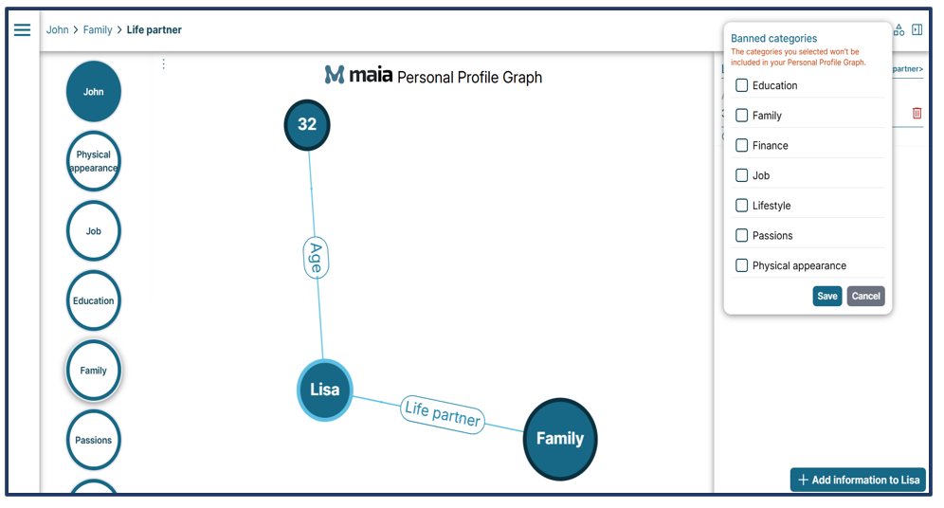

***IN A FEW CLICKS: How to hide a NODE from your PPG***

1. *Click the*  *icon in the top right corner*
2. *Choose the NODES you don’t want to be displayed on your graph*
3. *Click “Save”*

**Note: We recommend entering as much information as possible into your Personal Profile Graph. This way, Maia can use your data to give you the most accurate and customised answers.**

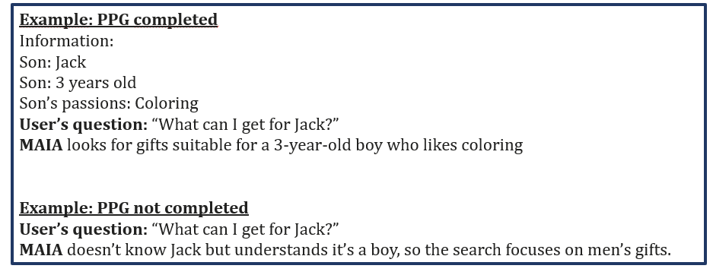

**3.2 My files**

My files is a personal space where users can upload documents, website links, voice messages, and emails. Maia can perform various tasks on these files, like answering questions about their content, providing translations and summaries, and even audio transcriptions.

Let's take a look at what can be uploaded and how to do so.

Here is a list of files you can upload:

* Text files: TXT, PDF, DOCX, PPTX
* Images: JPG, PNG, TFF, BMP, GIF, WEBP
* Audio: AAC, WAV, MPEG, OGG, OPUS
* URL: (website links)

**3.2.1 How to upload documents to My files**

You have two ways to access your dedicated storage space and start uploading files. The first and quickest way is to go to the menu  in the top left corner and select “My files”. From there you can upload your files by clicking the “Add to folder” button in the upper right corner and choosing one of the items from the menu below:

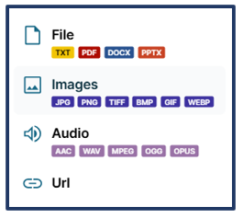

The second way allows you to upload a file and ask questions about its content. To do so, open a new chat by clicking the  button, and choose the box “Uknow: interact with Your Files”.

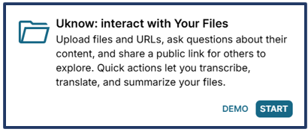

A pop-up will appear, giving you the option to upload files, enter a URL, or access the "My Files" section.

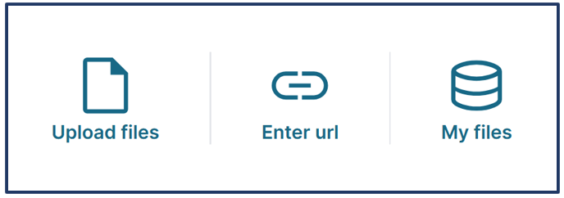

* Upload files
* Enter URL
* Access your personal space “My files”.

**Upload files**

Click “My Files” to open a pop-up where you can select a file from your device.

**Please note that the system allows file uploads up to a maximum of 5 MB.**

Once the file is uploaded, its title will appear above the search box, and the chat will display a message explaining the actions you can take on the document.

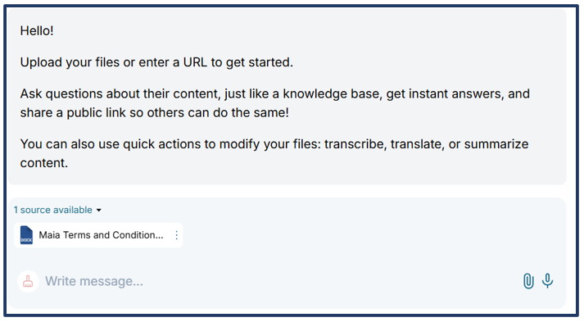

**Enter URL**

Once you click “Enter URL”, a pop-up with a box where to paste your website link will appear. Paste your link and click “Add”.

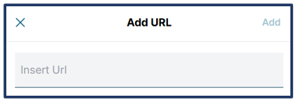

***IN A FEW CLICKS: How to upload a file to “My files”***

1. *Click on the section “Uknow: interact with Your Files”*



1. *Click “START”*
2. *Click “Upload files”*
3. *Choose the file you want to upload from your device*
4. *Wait until the file is fully uploaded*

***IN A FEW CLICKS: How to upload a URL to “My files”***

1. *Click on the section “Uknow: interact with Your Files”*



1. *Click “START”*
2. *Click “Enter URL”*
3. *Click “Add”*

You can easily send email content or any attachments you have received via email. Forward the email to [doc@mymaia.ai](mailto:doc@mymaia.ai) to add the email content and/or any attachments to “My files”.

**Accessing the My files space**

Click on the third button “My files” to view the files uploaded and sent via email.

Here you will see a screen featuring:

* The menu icon  in the top left corner
* A Create folder button , which is used to organize your files in your personal space
* The residual credit number in the lower left corner

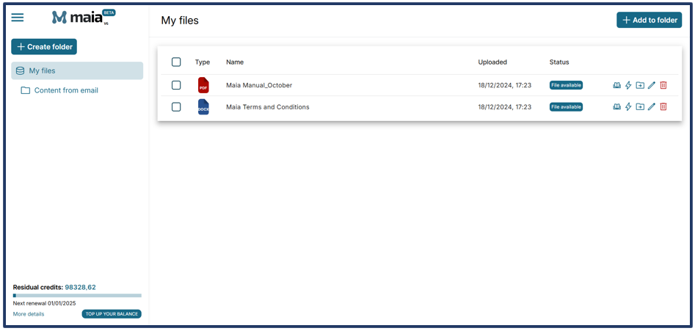

Now that you have customized your account and uploaded your documents, you are ready to make the most of Maia.

**4. MAIA’S TASKS AND FEATURES**

Maia can perform multiple tasks for different purposes. To make things easier, we have organized its features into four main sections.

- **Create Unique Images.** Here you can generate original images from simple text prompts using AI.

- **Create Original Texts.** Here you can generate custom texts from short paragraphs to longer and more complex content.

- **Uknow: interact with Your Files.** Here you can upload files and URLs and ask Maia about their content, generate a public link so that others can do the same, or use quick actions to transcribe, translate, and summarize your files.

**- Ufind: search for Information.** Here you can ask questions and get accurate answers from verified sources, whether it is news, local information or anything else.



Using these features is very easy. You just need to choose one box to open a new chat where you can interact with Maia and make the most of its tools.

**4.1 What is “Create Unique Images”?**

This is where Maia generates images using AI. Just like with web searches, you can share or download them to your device.

Maia creates detailed, high-quality images that span various styles and formats. The result is incredibly realistic and expressive, with a sharp focus on facial expressions and textures. The portraits are also extremely realistic.

**4.1.1 How “Create Unique Images” works**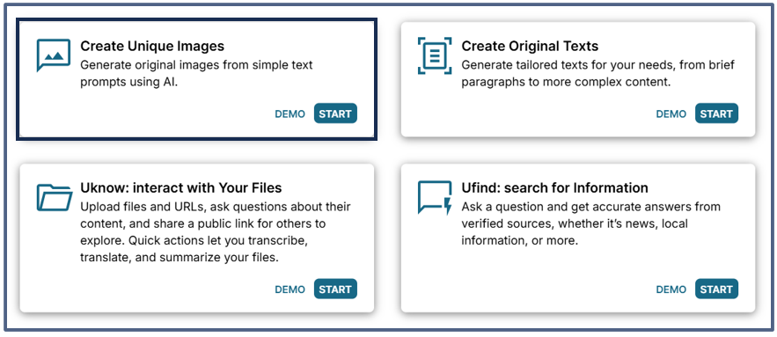

Let’s ask Maia to generate an image with a brief and simple text prompt: "Create an image of a child with a big smile on his face, eating a piece of chocolate cake".

Our request has been turned into the image below:



This image matches the user’s prompt and shows the feeling of fun. Maia has mainly focused on the details and facial expression, making the result look extremely realistic.

**4.2 What is “Create Original Texts”?**

This is where Maia generates a wide range of texts, including articles, contracts, podcasts, reports, and more.

**4.2.1. How “Create Original Texts” works**

To generate your text, click the "START" button in the "Create Original Text" box and use the search bar to give Maia instructions on the text you want to create.

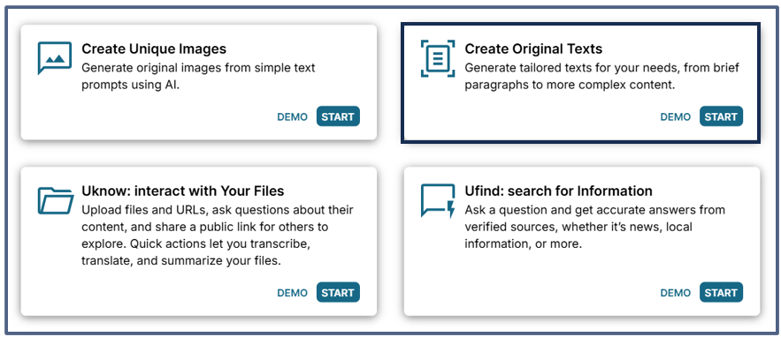

Let’s see a few examples:

1. Write an article about the story of Santa Claus

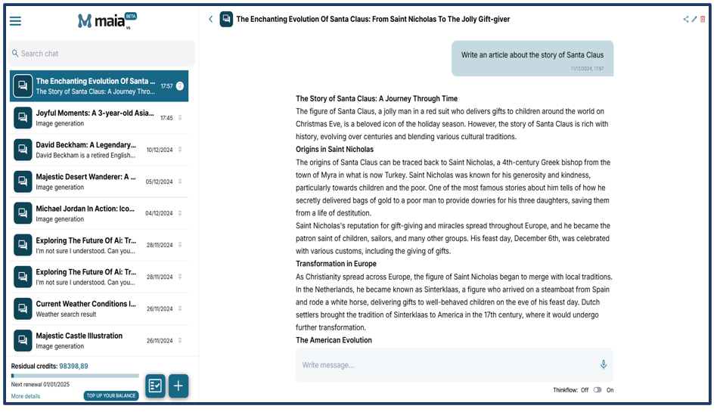

Maia has generated a text on the requested topic, following the proper structure and guidelines typical of an article.

1. Create a sales contract for a Xiaomi phone priced at €120 between Mr Jack Thompson and Ms Emma Wilson.

Note: This example only includes the buyer’s and seller’s names, leaving out sensitive information like tax numbers or addresses. Depending on the context, Maia adds placeholders and/or fictitious details Depending on the context, Maia adds placeholders and/or fictitious details which you will need to edit later. Although, in this case, the user hasn’t provided specific information on the buyer and seller, Maia has added placeholders to ensure the contract looks legally valid.

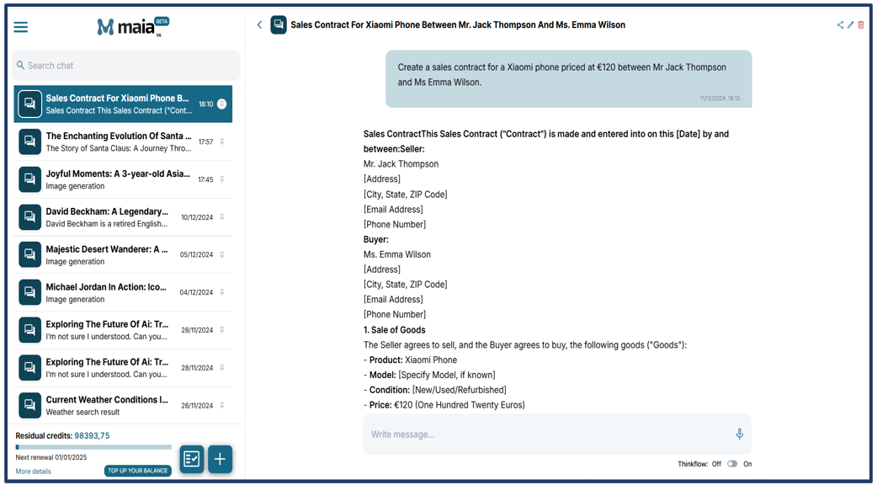

**4.3 What is “Uknow: interact with Your Files”?**

The “Uknow: interact with Your Files” feature, which leverages the “My files” storage space and Maia technology, allows you to upload texts, audio, images, and URLs. Once you upload your file, you can ask Maia questions about its content, translate or summarize it, and even ask for audio transcriptions.

**4.3.1 How the “Uknow: interact with Your Files” work**

To talk about this feature and understand how to use it, we need to go back to the description of the "My files" section.

As mentioned before, to use this feature, you will need to select one of the 4 boxes from the new chat screen.

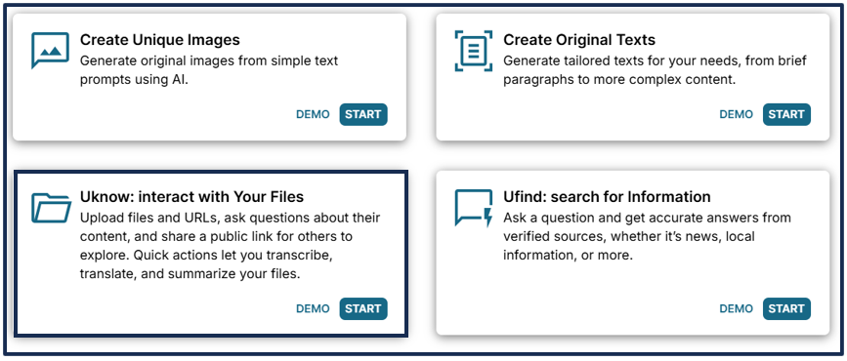

Clicking the "START" button will open a pop-up showing three options: "Upload files" "Enter URL" and "My files". Click the “My files” button to access this section, choose the file you want from the list, and drag it into the “Drag the file here” area.

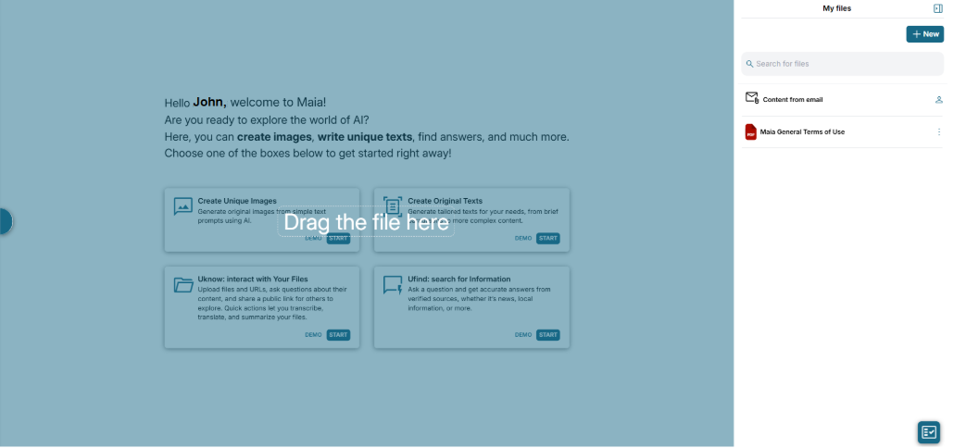

Now you will see the chat with the attached file above the search box.

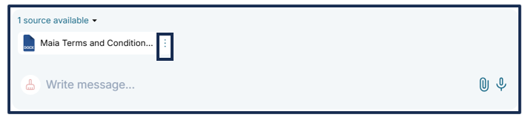

In the example above, the text is called “Maia Terms and Conditions”. Once you click the three-dot icon located on the right of the title, you will see a dropdown menu with the quick actions.

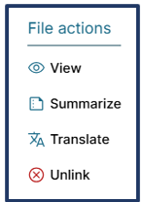

**View.** By clicking here, you can view the attached document.

**Summarize.** By clicking here, you are asking Maia to summarize the attached document.

**Translate.** By clicking here, you are asking Maia to translate the attached document.Once you proceed, a pop-up will open where you can choose the language for your translation. For English, Spanish, French, and Italian, click the corresponding flags. If you choose a language which is not in the flag list, click the symbol to view the complete list of languages for which Maia can provide a translation.

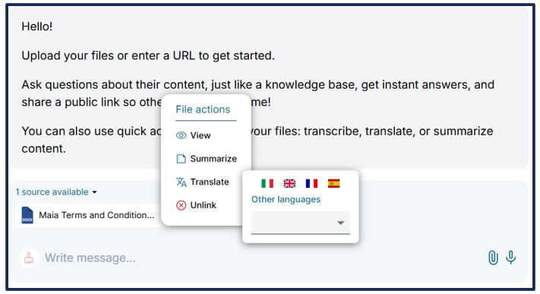

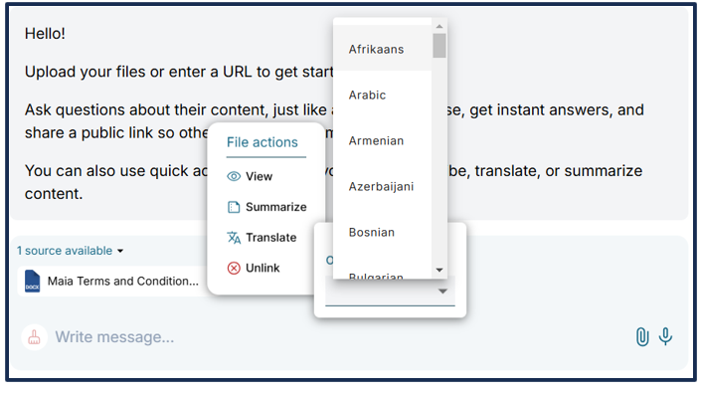

**Unlink.** By selecting this option, you are unlinking the document from the chat. Once you click here if no other documents are linked to that chat, you will see this screen:

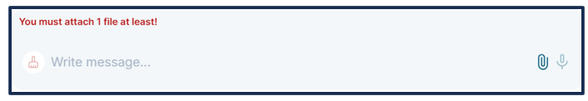

In addition to the quick actions, you can also **ask Maia specific questions** about the content of your document. Use the chat search box to type your request.

**4.4 What is “Ufind: search for Information”?**

This feature allows users to ask Maia questions and get accurate answers based on verified sources. You can request information on a variety of topics, by conducting standard web searches or more localized searches, which help find a business in a specific area.

**4.4.1 How “Ufind: search for Information” works**

To use this feature, click “START” in the corresponding box.

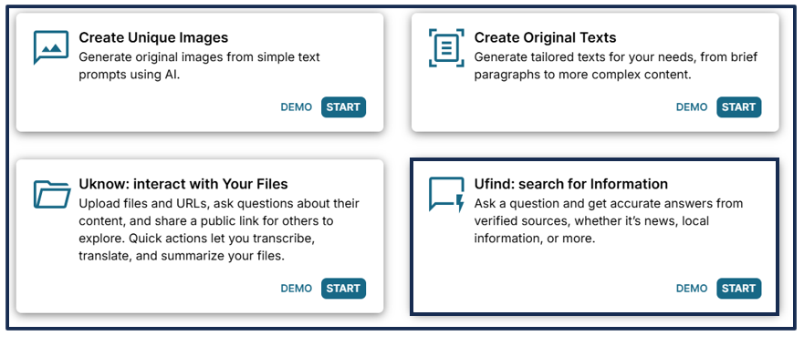

Once in a new chat, you can ask for information or advice by typing your request in the search box. Alternatively, you can use your voice to interact with Maia by clicking the microphone icon .

In this section, you can ask Maia questions and receive answers based on information found on the web. Remember that, if you activate geolocation and complete your Personal Profile Graph, Maia will be able to provide highly customized answers. Besides web searches, here you can carry out local searches and ask personal questions and interesting facts about Maia. Finally, you can also ask about your information to see how much Maia knows about you.

**4.4.2 Questions you can ask in the “Ufind: search for information” section**

* Web search. These are all the searches typically made on the web, including those that do not require any specific customization.

Example: Who’s David Beckham?

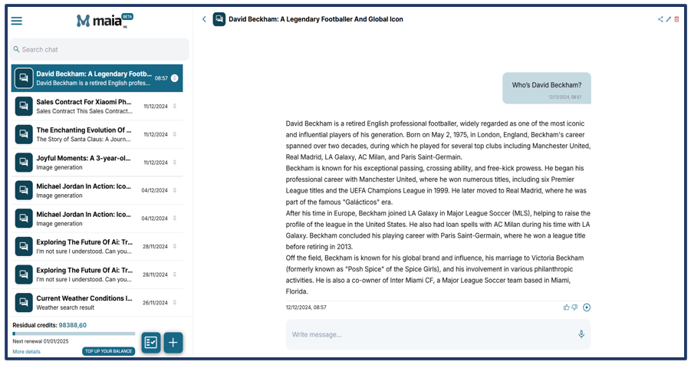

As mentioned earlier, clicking the icon in the top right corner will open a pop-up that allows you to share the conversation on Facebook, WhatsApp, X, LinkedIn, and via email.

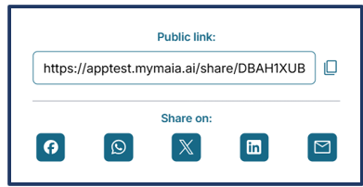

The buttons allow you to send feedback on an answer - with a thumb up standing for positive feedback and a thumb down for negative feedback, as well as listen to Maia’s responses. This last feature uses Text-to-Speech technology, which is especially handy if you can’t listen to the answer.

**4.4.3 The importance of the context**

Maia can identify the subject of the sentence even if it is not explicitly stated, inheriting it from the previous interaction. In our example, the user asks who David Beckham is and moves on to their second question "How many children does he have?". Although the subject, David Beckham, is not specified, Maia can still understand it from the previous context.

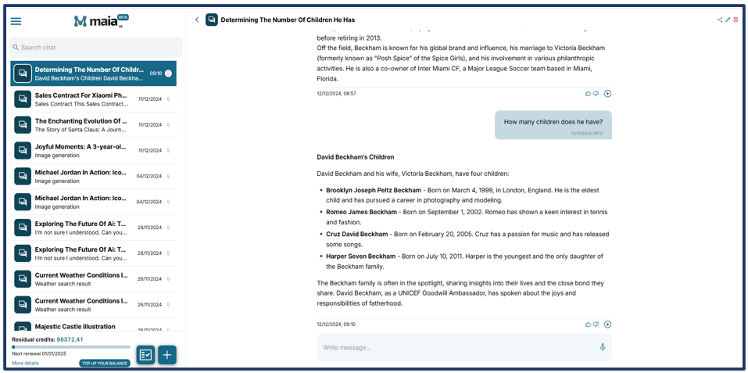

Maia has answered the question including information about David Beckham’s children’s names, ages, and interests. As you can see from the example, there has been no need to specify the subject of the question as the context has carried over the information that Maia understood and used to search.

* Local search. This search helps find a business in a specific area, whether is close to the user’s address or located in another city.

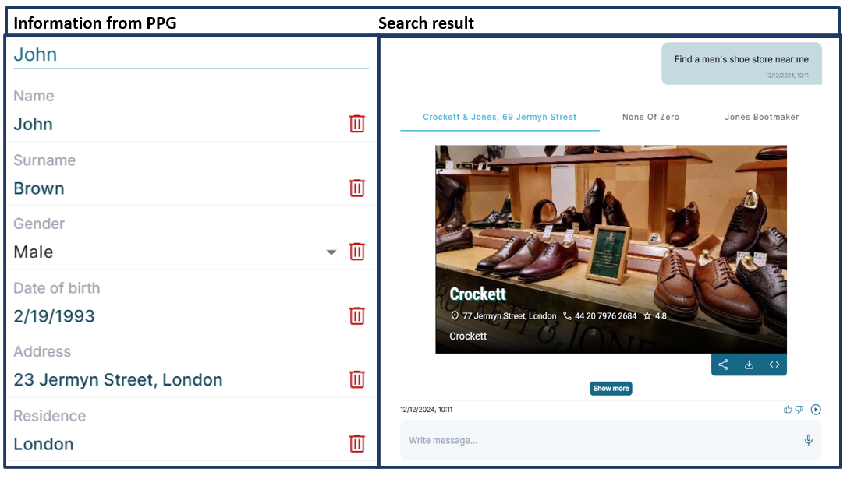

In this example, the user, John Brown, has entered information about his residence and home address (23 Jermyn Street, London) into their Personal Profile Graph.

Maia has leveraged this information to conduct a search and find men’s shoe stores in the area closest to the user’s address, which is 23 Jermyn Street, London.

The Media Cards that appear in the results provide an overview of the searched business, including the name, address, opening and closing hours, and, most importantly, customer ratings.

**Note: These cards and the details they provide don’t depend on any malfunction of Maia, but rather on whether information on that specific business is available online.**

As you can see, at the top, you can scroll through the found businesses that match the user's criteria.

* Personal search. With this search, you can learn more about Maia and how it can help you. You can ask Maia the same types of questions about yourself to see how much it knows about you.

***IN A FEW CLICKS: How to conduct a search***

1. *Click the “+” button in the bottom left corner to open a new chat.*
2. *Choose the "Ufind: search for information" box.  
    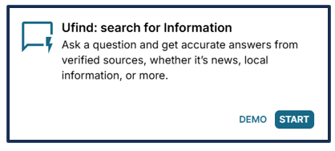*
3. *Click “Start”*
4. *Type your question in the search box*
5. *Press “Enter”*

*Types of searches:*

* *Web search*
* *Local search*
* *Personal search*

**5. PRICING**

Maia is an AI product that works through a credit system called Maia Credits. This system allows you to use credits only for the specific tasks or requests you actually need, ensuring no credits are left unused.

As mentioned earlier, when making your purchase, you can choose between two types of plans:

* **Maia Free**: has no fixed monthly costs and provides 50 free Maia Credits per month which you can use for any Maia feature.
* **Maia Elite:** has a fixed cost of only €5 per month and provides 500 Maia Credits, with automatic monthly renewal.

The Maia Free plan allows unlimited access to all types of requests, with the only limitation being the 50 credits available. Once the credits are used up, the service will be unavailable until the plan is renewed for free, after which you will receive another 50 credits, as provided for in the Free plan.

**If you think that the 50 monthly credits on the Free plan are not enough for your needs, you will have to upgrade to the Elite plan to get additional credits. Purchasing extra credit packages is not possible with the Free plan.**

The Elite plan not only comes at a very competitive price of just 5 euros per month, but it also provides 500 credits, which results in more interactions with Maia. **If you run out of credits on the Elite plan, you can always purchase extra credit packages.**

We offer three types of extra credit packages:

* Small: 500 Maia Credits
* Medium: 1000 Maia Credits
* Large: 3000 Maia Credits

Remember that the credits you purchase from the extra credit packages are valid and can only be used while your Elite plan is active. If you don’t renew your subscription after 3 months, the account will switch to the Free plan with 50 credits, and any extra credits you have bought won't be available. However, if you renew the Elite plan, those credits will become available again.

**5.1 Payment Methods**

To start using Maia, the payment methods are:

* Credit cards (Visa, Mastercard, Amex, UnionPay)
* Google Pay, Apple Pay
* Utake Payment"

The Elite plan has a fee of 5 euros, which will be charged every month. When you renew by making your next payment, the 500 Maia Credits will be automatically added to your Maia account.